**2018 PEW RESEARCH CENTER’S AMERICAN TRENDS PANEL**

**WAVE 35 May 2018**

**May 29 – June 11, 2018[1]**

Base: ASK ALL

*Scripter: Randomize and record response order*

**ALG1 [S]**

Which of the following statements comes closest to your view, even if neither is exactly right?

1. It is possible for computer programs to make decisions without human bias
2. Computer programs will always reflect the biases of the people who designed them

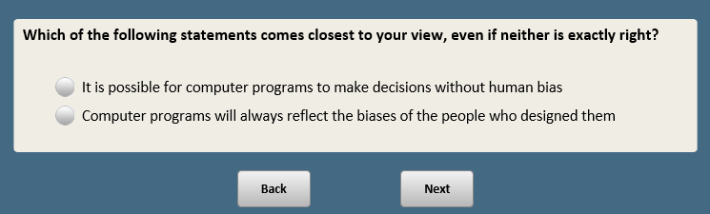

Base: ASK ALL

*Scripter: Randomize and record order of items a-d and e-h*

*Scripter: Randomize and record order of responses 1 and 2. Always anchor 3.*

**ECIMP [S]**

How much power and influence do you think each of the following have in today’s ECONOMY?

a. **[XFORM=1]** Technology companies

1. Too much power and influence
2. Not enough power and influence
3. About the right amount **[anchor]**

b. **[XFORM=1]** The energy industry

1. Too much power and influence
2. Not enough power and influence
3. About the right amount **[anchor]**

c. **[XFORM=1]** Labor unions

1. Too much power and influence
2. Not enough power and influence
3. About the right amount **[anchor]**

d. **[XFORM=1]** Banks and other financial institutions

1. Too much power and influence
2. Not enough power and influence
3. About the right amount **[anchor]**

e. **[XFORM=2]** Advertisers

1. Too much power and influence
2. Not enough power and influence
3. About the right amount **[anchor]**

f. **[XFORM=2]** Pharmaceutical companies

1. Too much power and influence
2. Not enough power and influence
3. About the right amount **[anchor]**

g. **[XFORM=2]** The farming and agriculture industry

1. Too much power and influence
2. Not enough power and influence
3. About the right amount **[anchor]**

h. **[XFORM=2]** Small businesses

1. Too much power and influence
2. Not enough power and influence
3. 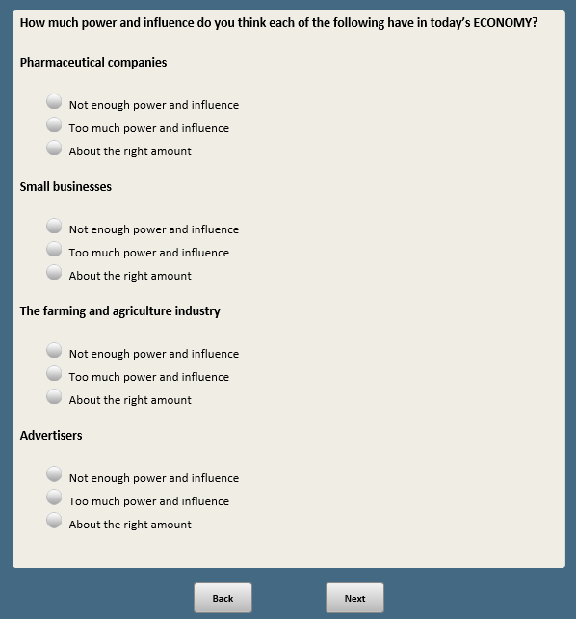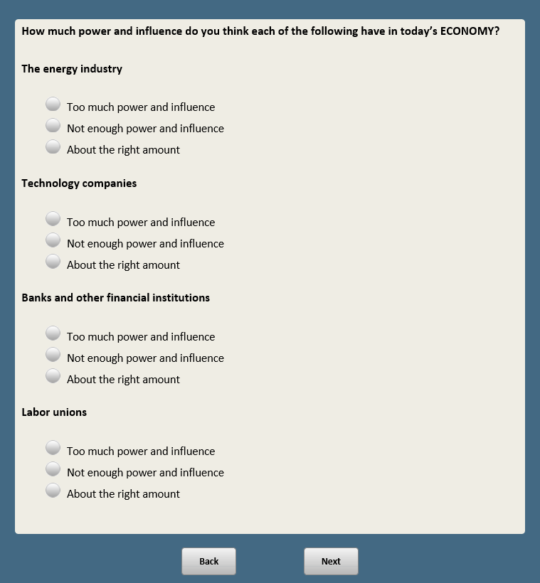About the right amount **[anchor]**

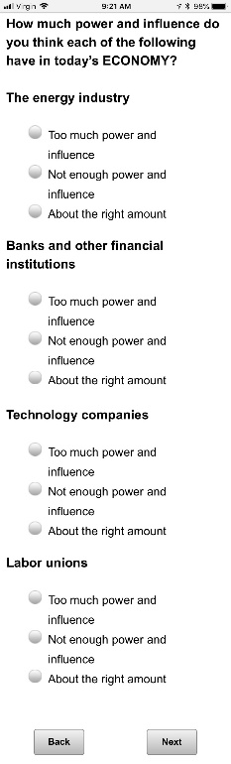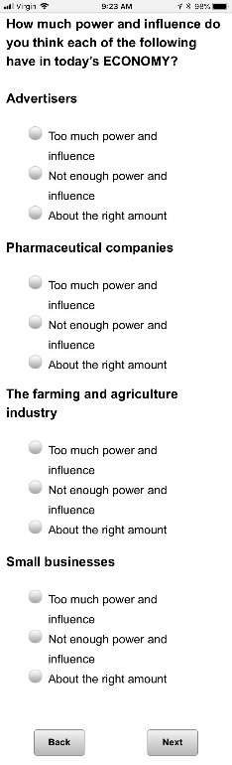

BASE: ASK IF XFORM=1

*Scripter: Allow as many characters as possible*

**TC1F1 [O]**

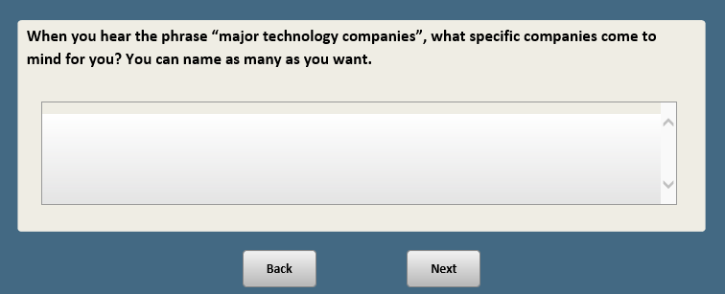When you hear the phrase “major technology companies”, what specific companies come to mind for you? You can name as many as you want.

BASE: ASK IF XFORM=2

*Scripter: Allow as many characters as possible*

**TC1F2 [O]**

When you think about major technology companies and the products and services they offer, what sorts of words come to mind for you? You can list as many as you want.

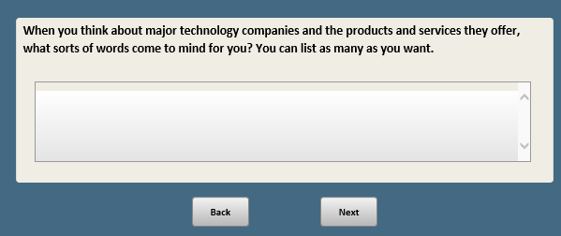

BASE: ASK ALL

**TC2a [S]**

How much of the time do you think you can trust major technology companies to do what is right?

1. Just about always
2. Most of the time
3. Some of the time
4. Hardly ever

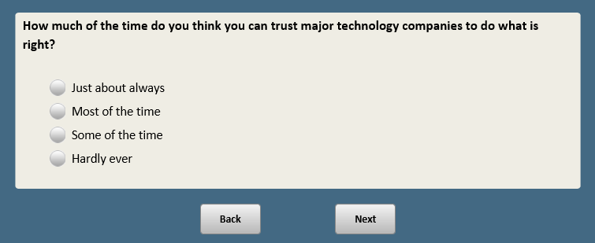

*Scripter: Randomize and record order of TC2b and TC2c. Show on same screen.*

BASE: ASK ALL

*Scripter: Randomize and record response order. Show in same order as TC2c*

**TC2b [S]**

Thinking about the impact major technology companies and their products and services have had on SOCIETY, do you think that impact has been…

1. More good than bad
2. More bad than good

ASK ALL

*Scripter: Randomize and record response order. Show in same order as TC2b*

**TC2c [S]**

Thinking about the impact major technology companies and their products and services have had on YOU PERSONALLY, do you think that impact has been…

1. More good than bad
2. 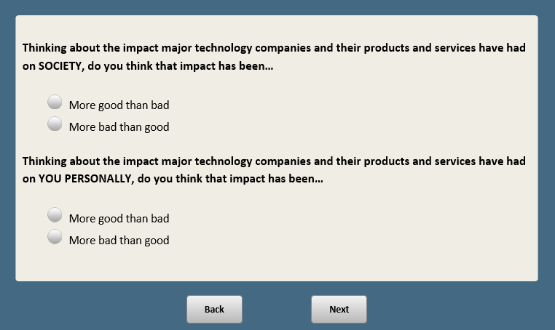More bad than good

BASE: ASK ALL

*Scripter: Randomize and record items a-c*

**TC3 [S]**

Do you think the following statements describe major technology companies well?

a. Their products and services mostly benefit people who already have advantages in life

1. Describes them well
2. Does not describe them well

b. They do enough to protect the personal data of their users

1. Describes them well
2. Does not describe them well

c. They often fail to anticipate how their products and services will impact society

1. Describes them well
2. Does not describe them well

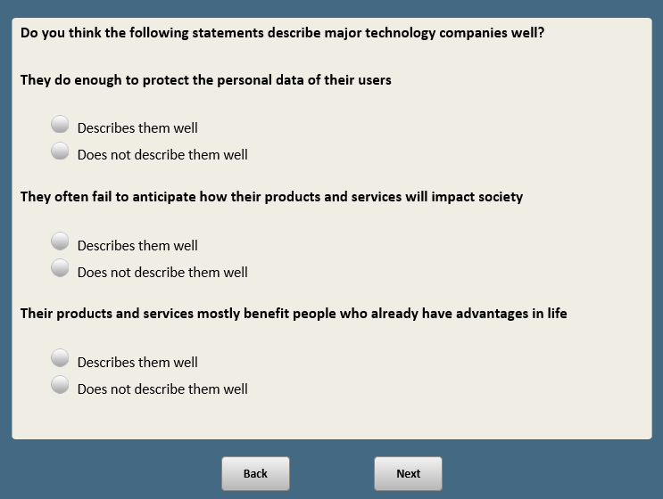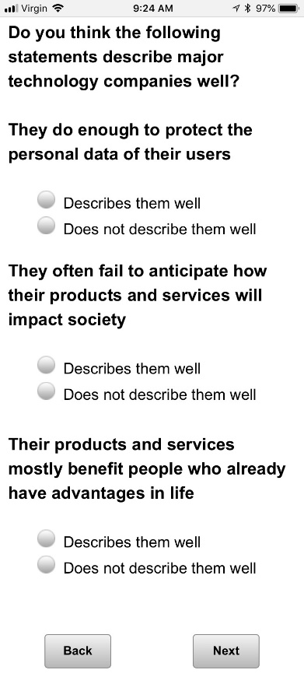

BASE: ASK ALL

*Scripter: Randomize and record responses 1 and 2. Anchor 3 last*

**TC4 [S]**

Compared to other companies, do you think major technology companies are…

1. More ethical
2. Less ethical
3. About as ethical as other companies **[anchor]**

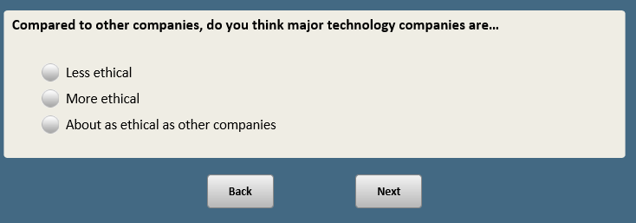

BASE: ASK ALL

*Scripter: Randomize and record responses 1 and 2. Anchor 3 last*

**TC5 [S]**

Thinking about the role of the government in regulating major technology companies, do you think these companies should be regulated…

1. More than they are now
2. Less than they are now
3. About the same as they are now **[anchor]**

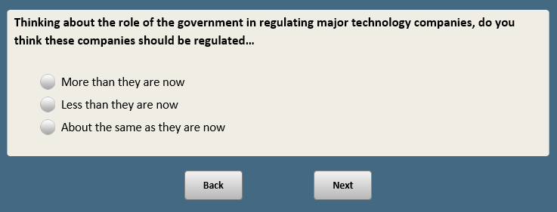

*Scripter: Randomize and record order of TC6a and TC6b. Show on same screen.*

Base: ASK ALL

*Scripter: Randomize and record order of responses 1 and 2. Anchor 3 last*

**TC6a [S]**

Do you think major technology companies tend to…

1. Support the views of men over women
2. Support the views of women over men
3. Support the views of both equally **[anchor]**

Base: ASK ALL

*Scripter: Randomize and record order of responses 1 and 2. Anchor 3 last*

**TC6b [S]**

Do you think major technology companies tend to…

1. Support the views of liberals over conservatives
2. Support the views of conservatives over liberals
3. Support the views of both equally **[anchor]**

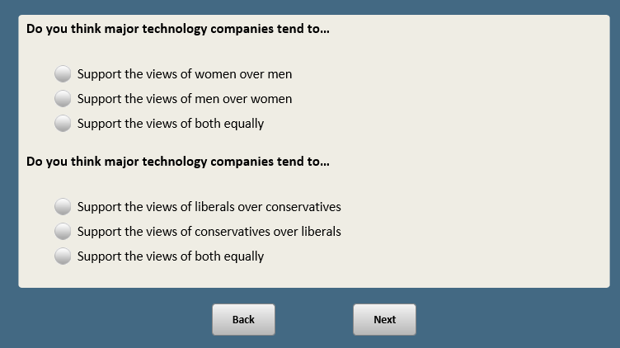

BASE: ASK ALL

*Scripter: Randomize and record response order. Anchor l last.*

*Custom Prompt if refused:* You have not selected any of the sites. If this is correct, click Next.

*Custom Prompt if “other” selected and nothing in text box:* You did not provide a response in the text box. If you would like to skip, click Next.

**SNS [M]**

On a different subject…

Do you use any of the following social media sites?{Based on Wave 28; ATP NM/ME; Twitter 2015; Facebook 2013, W14}

*[Check all that apply]*

a. Facebook {Wave 28}

b. Twitter {Wave 28}

**NO ITEM C**

**NO ITEM D**

e. Instagram {Wave 28}

**NO ITEM F**

**NO ITEM G**

h. YouTube {Wave 28}

**NO ITEM I**

j. Snapchat {Wave 28}

**NO ITEM K**

l. Other **[O]**

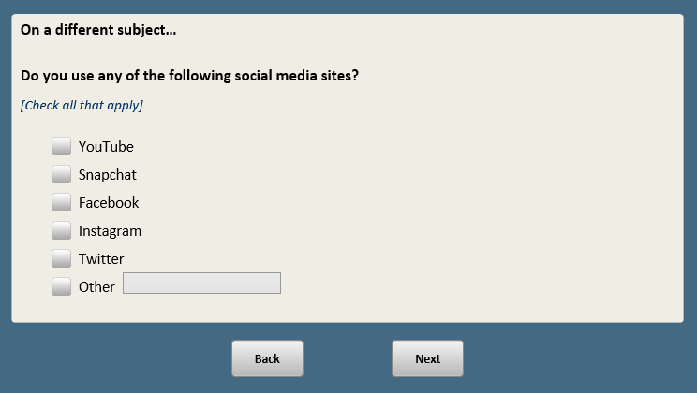

**CREATE DOV SNSUSER.**

**SNSUSER=1 “SOCIAL MEDIA USERS” IF ANY ITEM AT SNS SELECTECT (ANY SNSa-SNSl=1).**

**SNSUSER=0 “NOT SOCIAL MEDIA USER” IF SNS=refused**

Base: SNSa=1 OR SNSh=1 (ASK IF FACEBOOK OR YOUTUBE USER)

*Scripter: Show in same order as SNS*

**SNSFR [S]**

About how often do you use or visit the following…

a. **[SNSa=1]** Facebook

1. Several times a day
2. About once a day
3. Less often

b. **[SNSh=1]** YouTube

1. Several times a day
2. About once a day
3. Less often

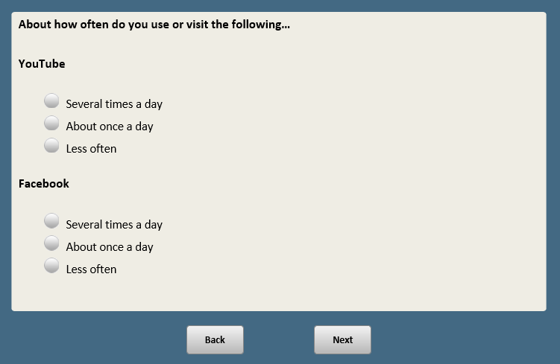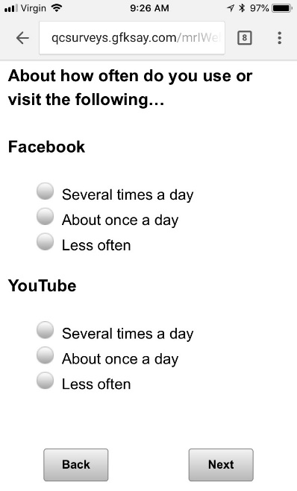

BASE: ASK ALL

*Scripter: Randomize and record order of items a-f*

*Scripter: Split across two screens*

**SM1 [S]**

How often, if ever, do you **[IF SNSUSER=1:**see **/** **IF SNSUSER=0:**hear about**]** content on social media that makes you feel…

a. Angry

1. Frequently
2. Sometimes
3. Hardly ever
4. Never

b. Inspired

1. Frequently
2. Sometimes
3. Hardly ever
4. Never

c. Amused

1. Frequently
2. Sometimes
3. Hardly ever
4. Never

d. Depressed

1. Frequently
2. Sometimes
3. Hardly ever
4. Never

e. Connected

1. Frequently
2. Sometimes
3. Hardly ever
4. Never

f. Lonely

1. Frequently
2. Sometimes
3. Hardly ever
4. Never

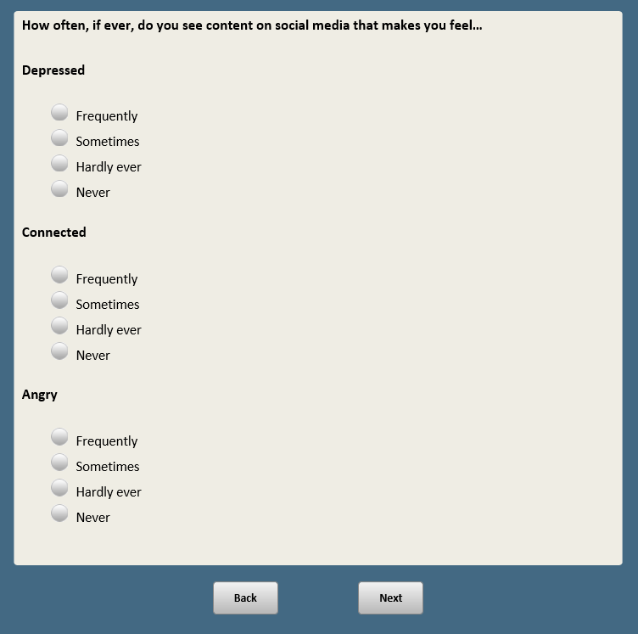 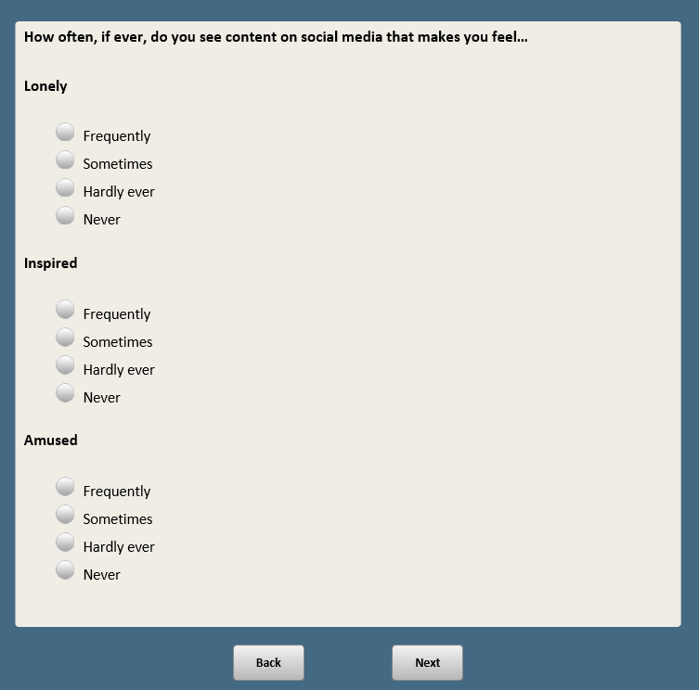

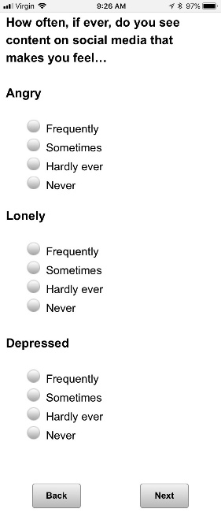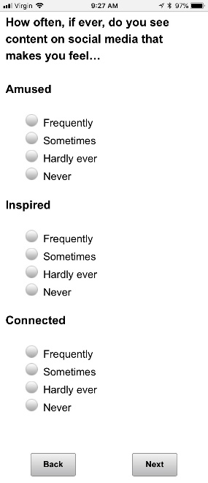

Base: SNSUSER=1 (ASK IF SOCIAL MEDIA USER)

*Scripter: Randomize and record order of items a-d*

**SM2 [S]**

How often, if ever, do you see the following things on social media?

a. Posts that are overly dramatic or exaggerated

1. Frequently
2. Sometimes
3. Hardly ever
4. Never

b. Posts that appear to be about one thing but turn out to be about something else

1. Frequently
2. Sometimes
3. Hardly ever
4. Never

c. Posts that teach you something useful that you hadn’t known before

1. Frequently
2. Sometimes
3. Hardly ever
4. Never

d. People making accusations or starting arguments without waiting until they have all the facts

1. Frequently
2. Sometimes
3. Hardly ever
4. Never

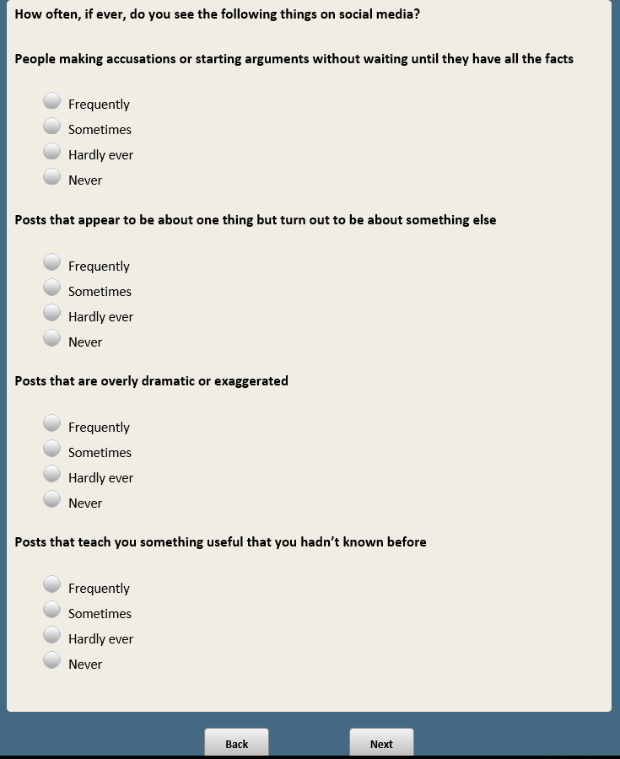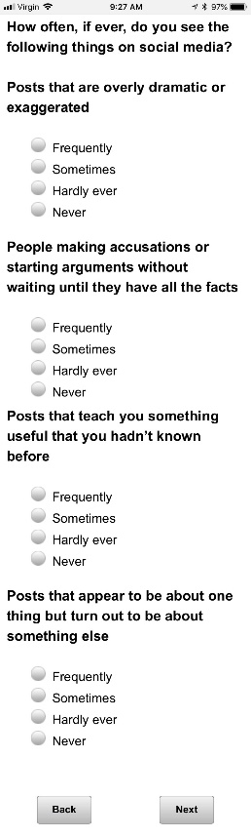

BASE: ASK ALL

**SM3 [S]**

In general, would you say that the content posted on social media provides an accurate picture of how society as a whole feels about important issues?

1. Provides an accurate picture
2. Does not provide an accurate picture

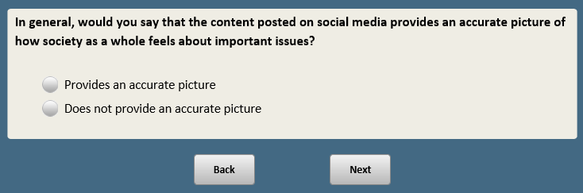

Base: SNSUSER=1 (ASK IF SOCIAL MEDIA USER)

*Scripter: Randomize and record order of items a-d*

**SM4 [S]**

Based on the data they have collected about you, how easy do you think it would be for the social media sites you use to figure out…

a. Your hobbies and interests

1. Very easy
2. Somewhat easy
3. Somewhat difficult
4. Very difficult

b. Your political affiliation

1. Very easy
2. Somewhat easy
3. Somewhat difficult
4. Very difficult

c. Your religious beliefs

1. Very easy
2. Somewhat easy
3. Somewhat difficult
4. Very difficult

d. Your race or ethnicity

1. Very easy
2. Somewhat easy
3. Somewhat difficult
4. Very difficult

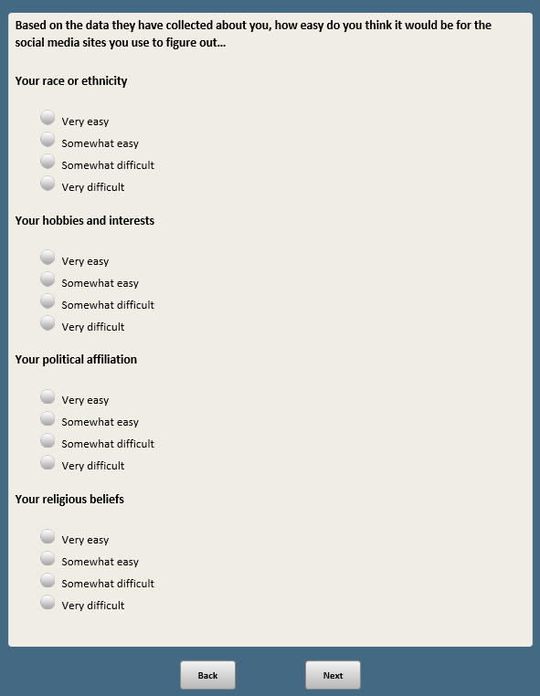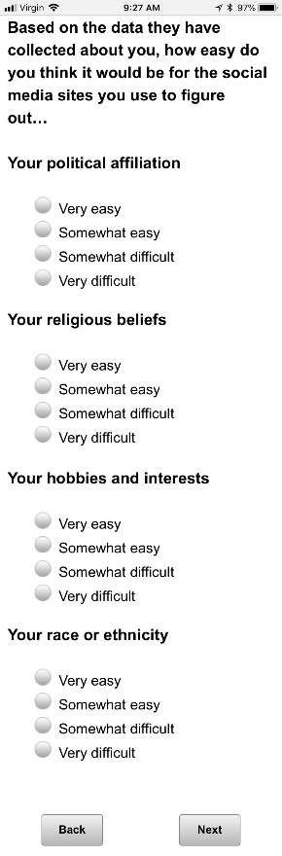

Base: SNSUSER=1 (ASK IF SOCIAL MEDIA USER)

*Scripter: Randomize and record order of items a-d*

**SM5 [S]**

How acceptable, if at all, do you think it is for social media sites to use data about you and your online activities to…

a. Recommend events in your area

1. Very acceptable
2. Somewhat acceptable
3. Not very acceptable
4. Not acceptable at all

b. Show you advertisements for products or services

1. Very acceptable
2. Somewhat acceptable
3. Not very acceptable
4. Not acceptable at all

c. Recommend someone you might want to know as a friend

1. Very acceptable
2. Somewhat acceptable
3. Not very acceptable
4. Not acceptable at all

d. Show you messages from political campaigns

1. Very acceptable
2. Somewhat acceptable
3. Not very acceptable
4. Not acceptable at all

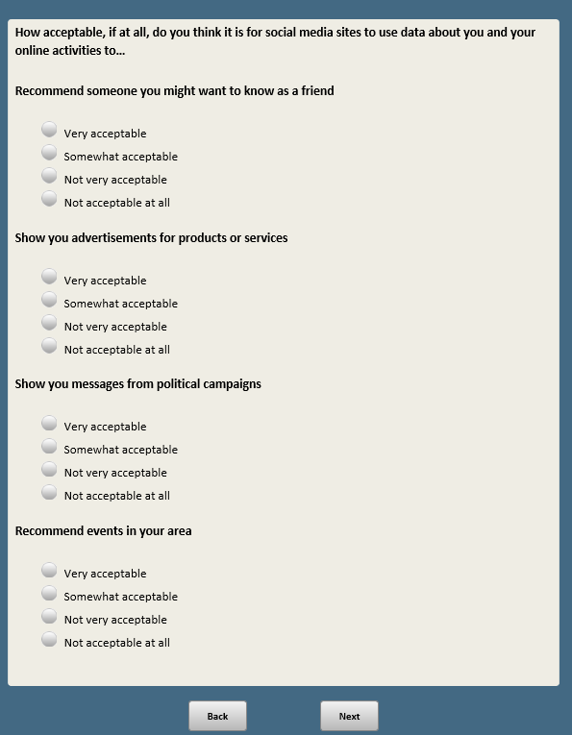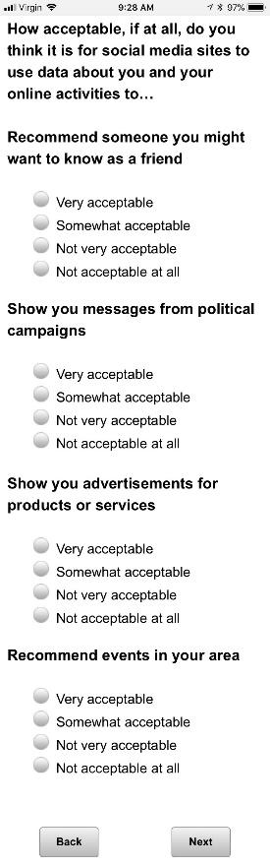

*Scripter: Randomize and record order of SM6a and SM6b. Show on same screen*

Base: SNSUSER=1 (ASK IF SOCIAL MEDIA USER)

*Scripter: Randomize and record order of responses 1 and 2. Anchor 3 last.*

**SM6a [S]**

Which of the following behaviors do you see more of on social media?

1. People being kind or supportive
2. People being mean or bullying
3. Equal mix of both **[anchor]**

Base: SNSUSER=1 (ASK IF SOCIAL MEDIA USER)

*Scripter: Randomize and record order of responses 1 and 2. Anchor 3 last.*

**SM6b [S]**

Which of the following behaviors do you see more of on social media?

1. People trying to be deceptive
2. People trying to point out inaccurate information
3. Equal mix of both **[anchor]**

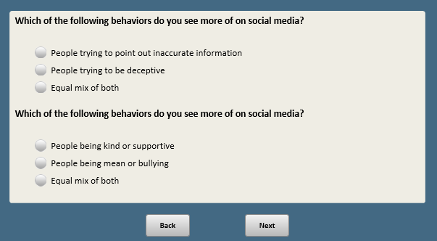

BASE: ASK ALL

**SM7 [S]**

How likely, if at all, do you think it is that social media sites intentionally censor political viewpoints that they find objectionable?

1. Very likely
2. Somewhat likely
3. Not very likely
4. Not at all likely

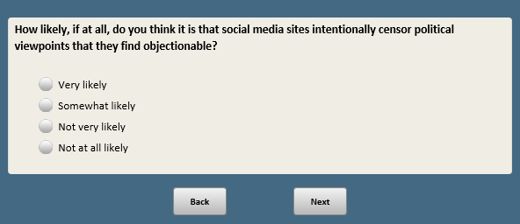

Base: SNSUSER=1 (ASK IF SOCIAL MEDIA USER)

*Scripter: Randomize and record order of items a-c*

**SM8 [S]**

Do you think it is acceptable or not acceptable for social media sites to do the following things?

a. Change the look and feel of their site for some users, but not others

1. Acceptable
2. Not acceptable

b. Remind some users, but not others, to vote on election day

1. Acceptable
2. Not acceptable

c. Show some users, but not others, more of their friends’ happy posts and fewer of their sad posts

1. Acceptable
2. Not acceptable

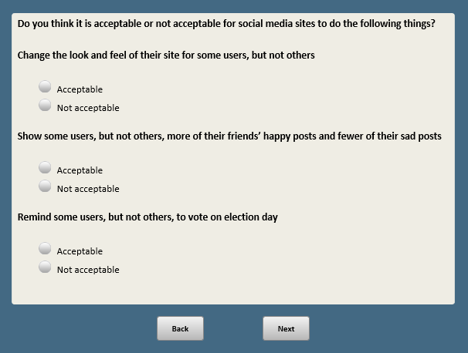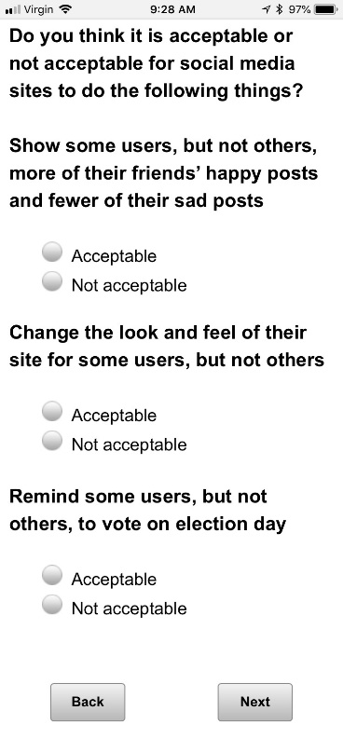

BASE: ASK ALL

*Scripter: Randomize and record order of items a-e*

**SM9 [S]**

Now thinking specifically about some of the ways that people use social media to engage with political or social issues that are important to them…

How well do you think each of the following statements describes social media?

a. Social media helps give a voice to underrepresented groups

1. Very well
2. Somewhat well
3. Not too well
4. Not at all well

b. Social media distracts people from issues that are truly important

1. Very well
2. Somewhat well
3. Not too well
4. Not at all well

c. Social media highlights important issues that might not get a lot of attention otherwise

1. Very well
2. Somewhat well
3. Not too well
4. Not at all well

d. Social media makes it easier to hold powerful people accountable for their actions

1. Very well
2. Somewhat well
3. Not too well
4. Not at all well

e. Social media makes people think they are making a difference when they really aren’t

1. Very well
2. Somewhat well
3. Not too well
4. Not at all well

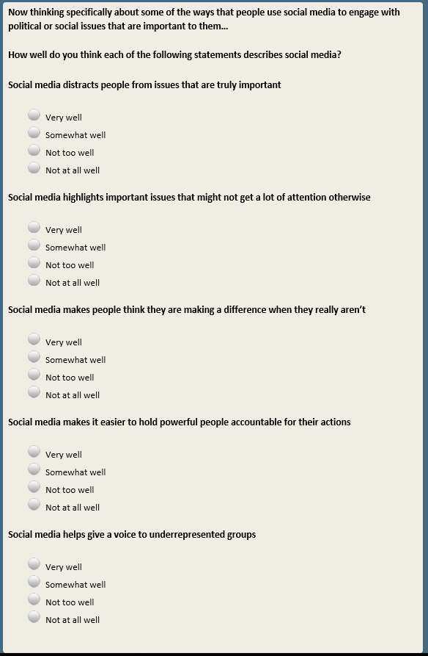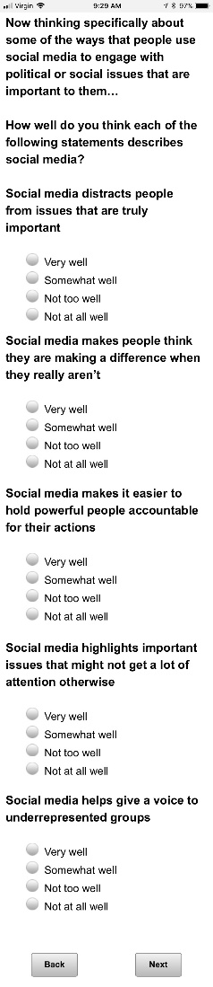

Base: SNSUSER=1 (ASK IF SOCIAL MEDIA USER)

*Scripter: Randomize and record order of items a-e*

**SM10 [S]**

Have you done any of the following activities on social media in the past year?

a. Changed your profile picture to show your support for a cause

1. Have done this in the past year
2. Have not done this in the past year

b. Used hashtags related to a political or social issue

1. Have done this in the past year
2. Have not done this in the past year

c. Taken part in a group that shares an interest in an issue or cause

1. Have done this in the past year
2. Have not done this in the past year

d. Encouraged others to take action on issues that are important to you

1. Have done this in the past year
2. Have not done this in the past year

e. Looked for information about rallies or protests happening in your area

1. Have done this in the past year
2. Have not done this in the past year

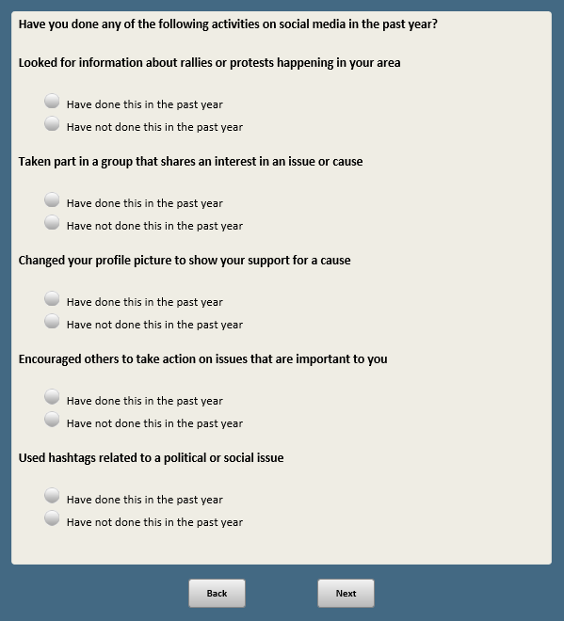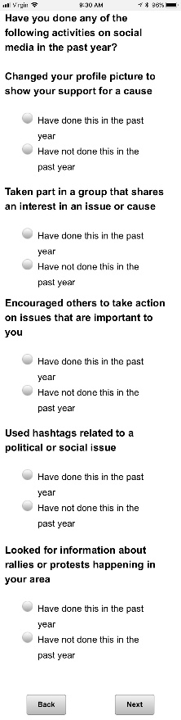

Base: SNSUSER=1 (ASK IF SOCIAL MEDIA USER)

**SM11 [S]**

In the past year, have you changed your views about a political or social issue because of something you saw on social media?

1. Have changed my views
2. Have not changed my views

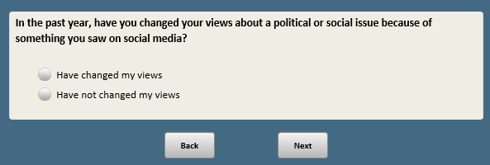

*Scripter: Randomize and record order of SM12 and SM13. Show on different screens*

Base: SNSUSER=1 (ASK IF SOCIAL MEDIA USER)

*Scripter: Randomize and record order of items a-c*

**SM12 [S]**

How important, if at all, is social media to you PERSONALLY when it comes to the following things?

a. Finding other people who share your views about important issues

1. Very important
2. Somewhat important
3. Not very important
4. Not important at all

b. Getting involved with political or social issues that are important to you

1. Very important
2. Somewhat important
3. Not very important
4. Not important at all

c. Giving you a venue to express your political opinions

1. Very important
2. Somewhat important
3. Not very important
4. Not important at all

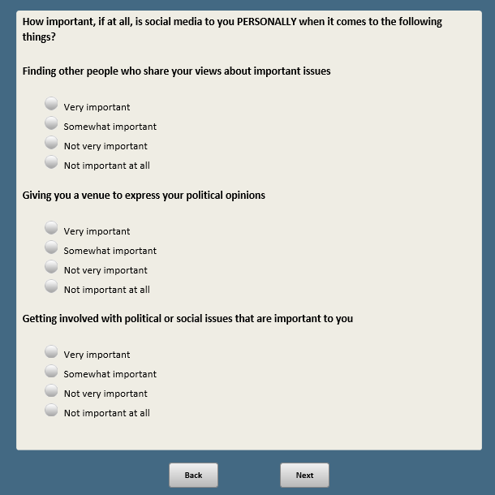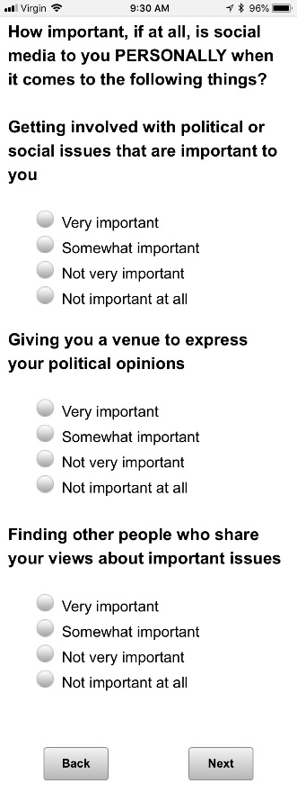

BASE: ASK ALL

*Scripter: Randomize and record order of items a-c*

**SM13 [S]**

In general, how important, if at all, do you think social media is today when it comes to the following things?

a. Getting elected officials to pay attention to issues

1. Very important
2. Somewhat important
3. Not very important
4. Not important at all

b. Influencing policy decisions

1. Very important
2. Somewhat important
3. Not very important
4. Not important at all

c. Creating sustained movements for social change

1. Very important
2. Somewhat important
3. Not very important
4. Not important at all

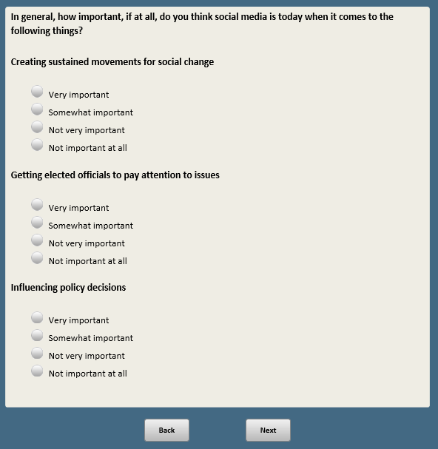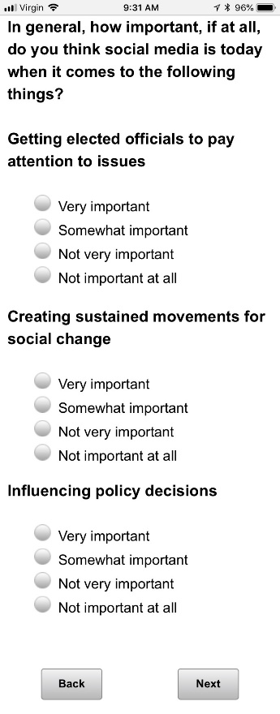

Base: SNSUSER=1 (ASK IF SOCIAL MEDIA USER)

*Scripter: Randomize and record order of items a-d*

**SM14 [S]**

Thinking about the content you SEE on social media, approximately how much content would you say is about…

a. Race or race relations

1. A great deal
2. Some
3. Only a little
4. None

b. Sexual harassment or assault

1. A great deal
2. Some
3. Only a little
4. None

c. Gun control or gun violence

1. A great deal
2. Some
3. Only a little
4. None

d. Immigration

1. A great deal
2. Some
3. Only a little
4. None

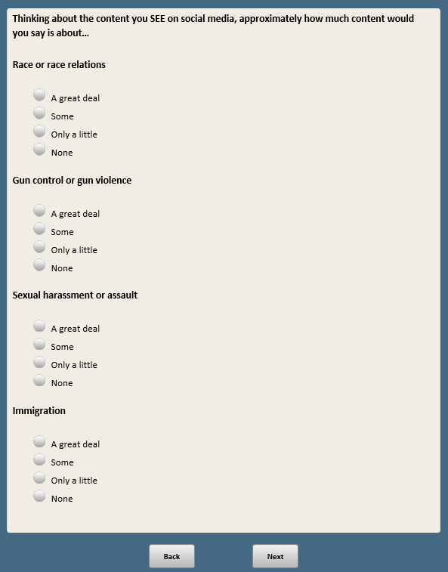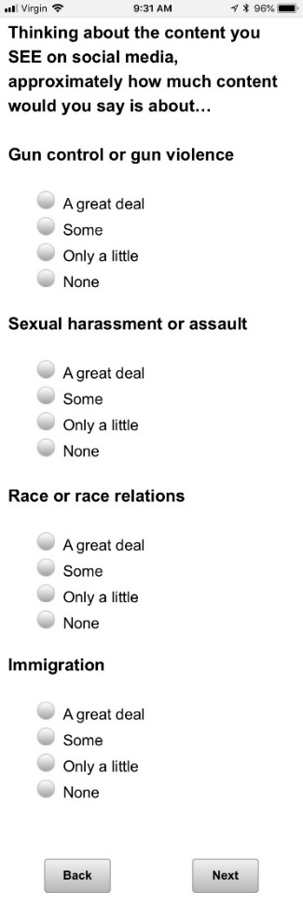

Base: SNSa=1 (ASK IF FACEBOOK USER)

**FB1 [S]**

Now thinking specifically about how you use FACEBOOK…

How much, if at all, do you feel you understand why certain posts are included in your Facebook News Feed and others are not? In the picture below, the News Feed is outlined in red.

**[if xspanish=1, show FB1_English2.png. If xspanish=2, show FB1_Spanish2.png]**

1. Very well
2. Somewhat well
3. Not very well
4. Not well at all

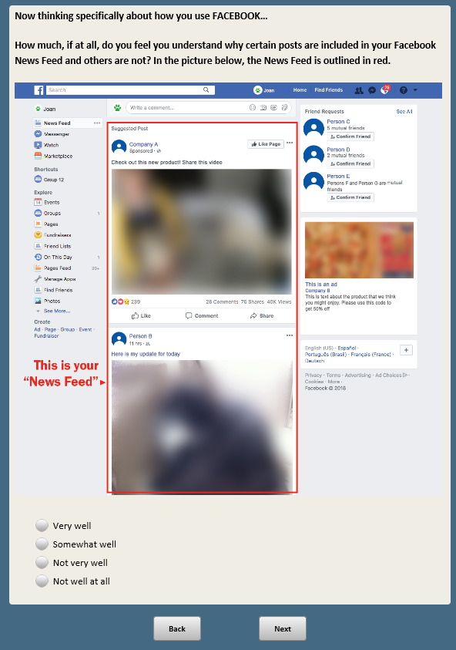

Base: SNSa=1 (ASK IF FACEBOOK USER)

**FB2 [S]**

How many of the posts that appear in your Facebook News Feed would you say are interesting and relevant to you?

1. Almost all of them
2. Most of them
3. Some of them
4. None of them

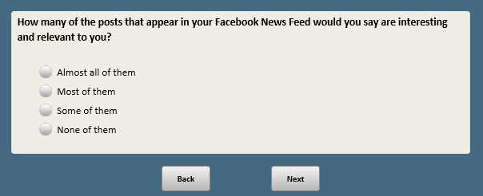

Base; SNSa=1 (ASK IF FACEBOOK USER)

*Scripter: Show FB3a and FB3b on the same screen*

**FB3a [S]**

How much control do you think users have over the content that appears in their Facebook News Feed?

1. A lot
2. A little
3. None

Base; SNSa=1 (ASK IF FACEBOOK USER)

*Scripter: Show FB3a and FB3b on the same screen*

**FB3b [S]**

Have you ever intentionally tried to influence or change the content you see on your Facebook News Feed?

1. Yes
2. No

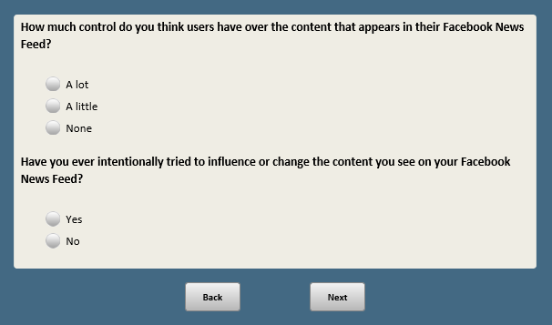

Base: FB3b=1 (ASK IF YES TO FB3b)

*Scripter: Randomize and record responses 1-5. Anchor 6 last*

*Custom prompt if 5 is selected and no text entered:* You did not provide a response in the text box. If you would like to skip, click Next.

**FB3c [M]**

What actions have you taken to try and influence what shows up in your Facebook News Feed?

*[Check all that apply]*

1. Friended or unfriended certain people
2. Liked, shared or commented on certain types of content
3. Indicated that you wanted to see less of certain people or types of content
4. Changed your privacy settings or ad preferences
5. Followed or unfollowed certain groups or organizations
6. Something else **[O] [anchor]**

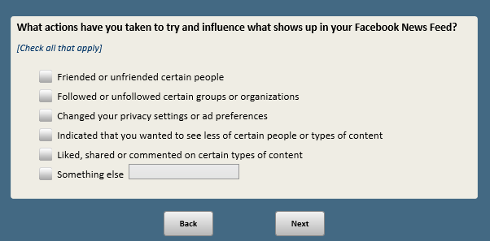

Base: SNSa=1 (ASK IF FACEBOOK USER)

*Scripter: Randomize and record order of items a-b*

**FB4 [S]**

How often does Facebook show you posts that remind you of a…

a. HAPPY time in your life

1. Frequently
2. Sometimes
3. Hardly ever
4. Never

b. SAD time in your life

1. Frequently
2. Sometimes
3. Hardly ever
4. Never

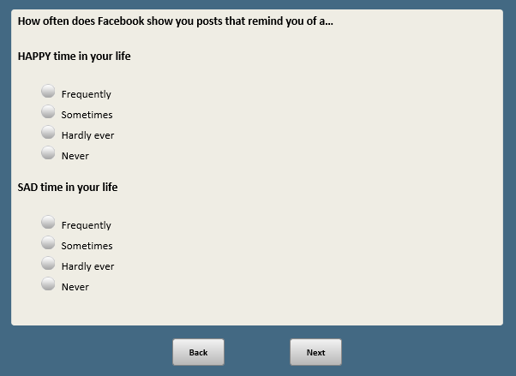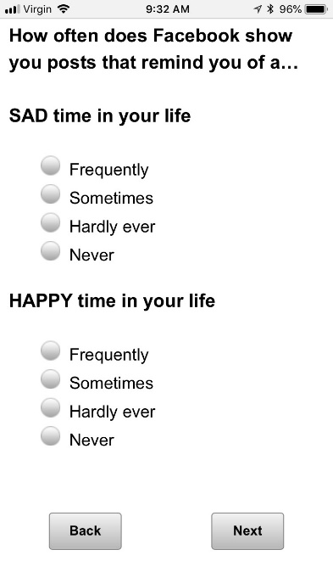

Base: SNSa=1 (ASK IF FACEBOOK USER)

*Scripter: Randomize and record order of items a-d*

**FB5 [S]**

In the past year, have you done any of the following things?

a. Taken a break from checking Facebook for a period of several weeks or more

1. Have done this in the past year
2. Have not done this in the past year

b. Deleted the Facebook app from your phone

1. Have done this in the past year
2. Have not done this in the past year

c. Adjusted your Facebook privacy settings

1. Have done this in the past year
2. Have not done this in the past year

d. Downloaded all the personal data Facebook has collected about you

1. Have done this in the past year
2. Have not done this in the past year

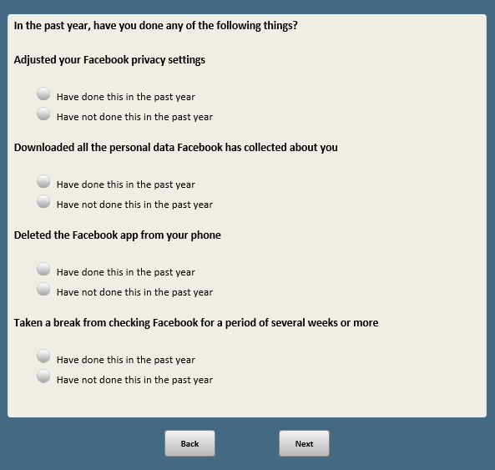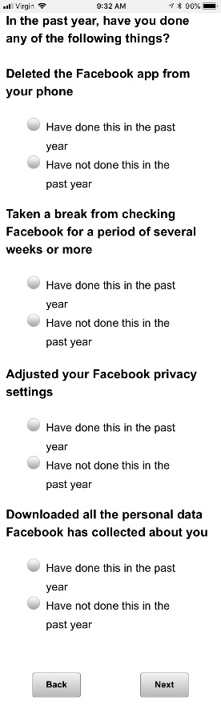

Base: SNSh=1 (ASK IF YOUTUBE USER)

*Scripter: Randomize and record order of items a-d*

**YT1 [S]**

Now thinking specifically about how you use YOUTUBE…

How important to you are videos on YouTube when it comes to...

a. Understanding things that are happening in the world

1. Very important
2. Somewhat important
3. Not very important
4. Not important at all

b. Figuring out how to do things you haven’t done before

1. Very important
2. Somewhat important
3. Not very important
4. Not important at all

c. Deciding whether you should buy a particular product or not

1. Very important
2. Somewhat important
3. Not very important
4. Not important at all

d. Just passing the time

1. Very important
2. Somewhat important
3. Not very important
4. Not important at all

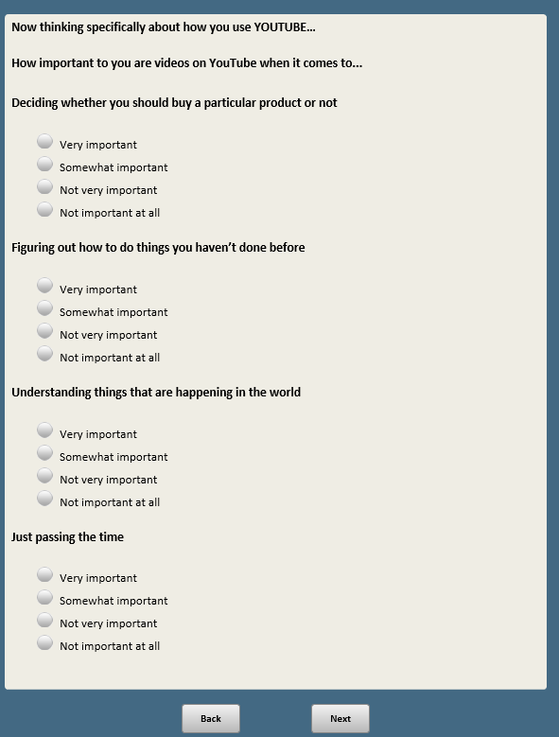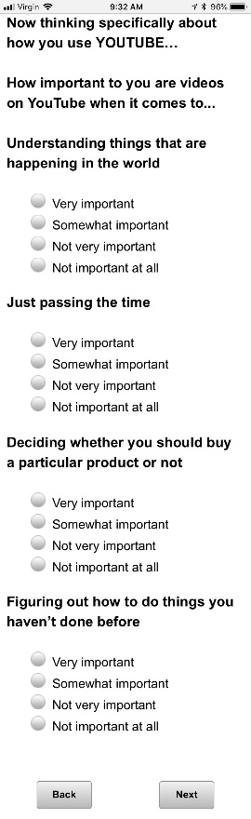

Base: SNSh=1 (ASK IF YOUTUBE USER)

**YT2 [S]**

When you watch videos on YouTube, do you also watch the recommended videos that appear alongside the video you are watching?

1. Yes, regularly
2. Yes, on occasion
3. No

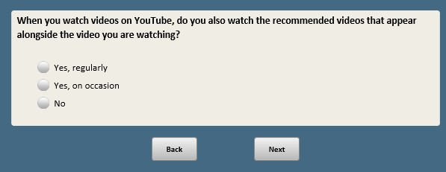

Base: SNSh=1 (ASK IF YOUTUBE USER)

*Scripter: Randomize and record order of items a-c*

**YT3 [S]**

How often, if ever, do you notice videos on YouTube that…

a. Seem obviously false or untrue

1. Frequently
2. Sometimes
3. Hardly ever
4. Never

b. Are abusive or demeaning towards others

1. Frequently
2. Sometimes
3. Hardly ever
4. Never

c. Show people engaging in dangerous or troubling behaviors

1. Frequently
2. Sometimes
3. Hardly ever
4. Never

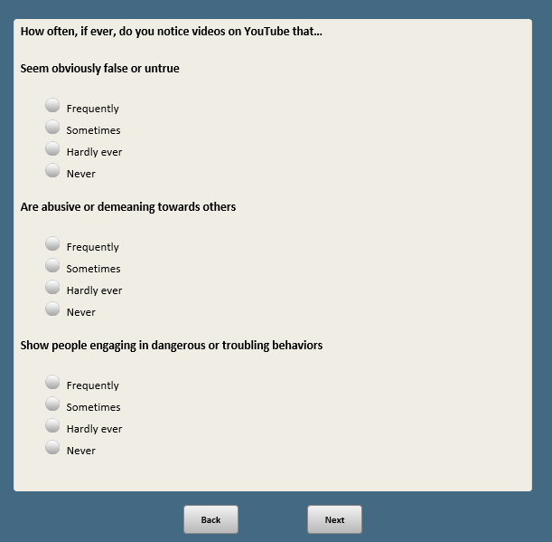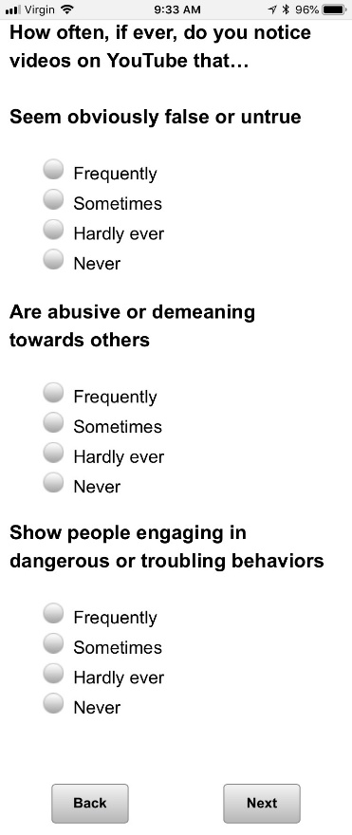

Base: ASK IF PARENT OF CHILD AGE 0-11

**YT4 [S]**

How often do you let your child or children age 11 or younger watch videos on YouTube?

1. Regularly
2. On occasion
3. Never

**[SPACE]**

1. I do not have any children age 11 or younger

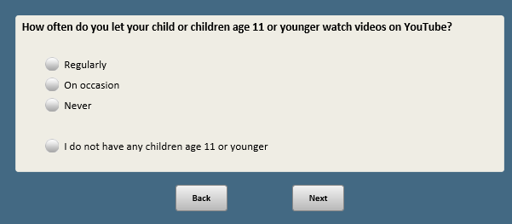

Base: YT4=1 or 2 (ASK IF YES TO YT4)

**YT5 [S]**

Has your child ever encountered content on YouTube that you thought was unsuitable for children?

1. Yes
2. No

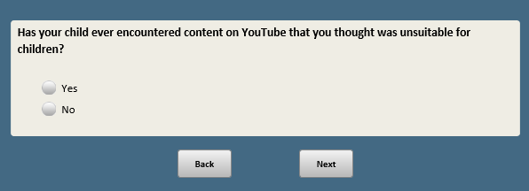

**Create V1 [S]**

**Randomly assign respondents into V1=1 or V1=2**

Base: ASK IF V1=1

**V1Q1 [S]**

Next, please think about the following situation…

Companies have developed automated programs to calculate a new type of personal finance score, similar to a credit score. These programs collect information from many different sources about people’s behavior and personal characteristics – such as their online habits or the products and services they use. They then assign people an automated score that helps businesses decide whether to offer them loans, special offers or other services.

How FAIR do you think this type of program would be to consumers?

1. Very fair
2. Somewhat fair
3. Not very fair
4. Not fair at all

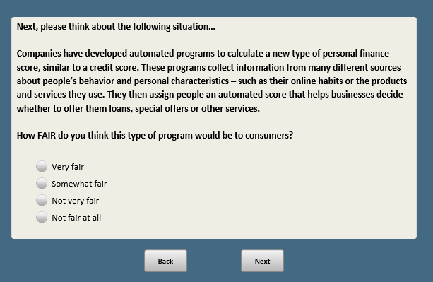

Base: ASK IF V1=1

**V1Q2 [S]**

How EFFECTIVE do you think this type of program would be at identifying people who would be good customers?

1. Very effective
2. Somewhat effective
3. Not very effective
4. Not effective at all

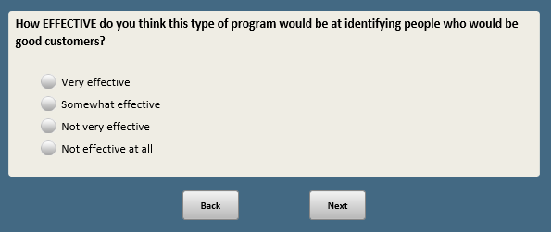

Base: ASK IF V1=1

**V1Q3 [S]**

Do you think it is acceptable or not for companies to use this type of program?

1. Acceptable
2. Not acceptable

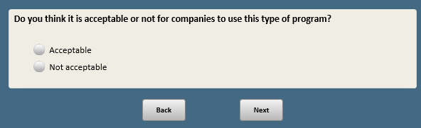

Base: ASK IF V1Q3=1 or 2

*Scripter: Allow as many characters as possible*

**V1Q4 [O]**

Why do you think this is **[IF V1Q3=2 show:**not**]** acceptable?

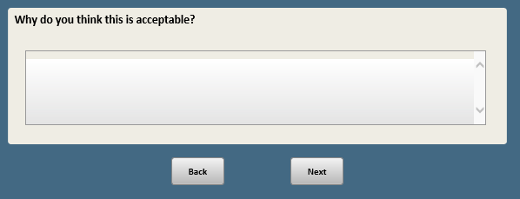

Base: ASK IF V1=2

**V2Q1 [S]**

Next, please think about the following situation…

Companies have developed automated programs to calculate a new type of criminal risk score for people in prison who may qualify for parole. These programs collect information from many sources about a person’s past behavior and personal characteristics. They then compare this data to others who have been convicted of crimes, and assign a score that helps decide whether someone should be released on parole or not.

How FAIR do you think this type of program would be to people in parole hearings?

1. Very fair
2. Somewhat fair
3. Not very fair
4. Not fair at all

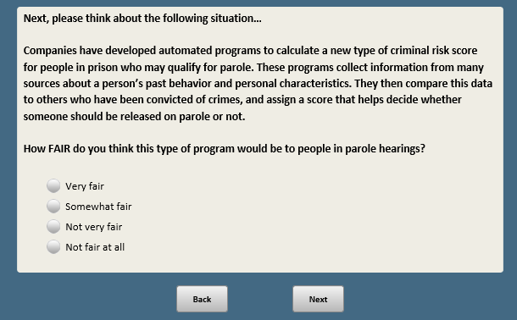

Base: ASK IF V1=2

**V2Q2 [S]**

How EFFECTIVE do you think this type of program would be at identifying people who are deserving of parole from prison?

1. Very effective
2. Somewhat effective
3. Not very effective
4. Not effective at all

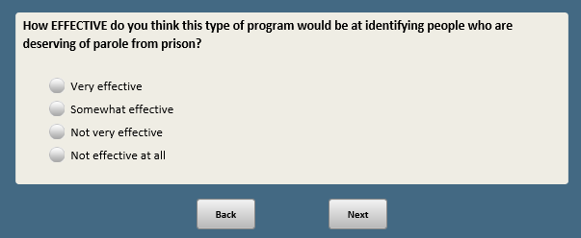

Base: ASK IF V1=2

**V2Q3 [S]**

Do you think it is acceptable or not for the criminal justice system to use this type of program?

1. Acceptable
2. Not acceptable

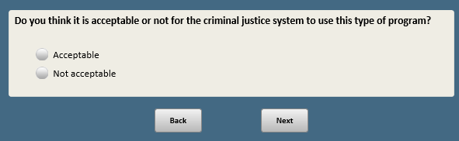

Base: ASK IF V2Q3=1 or 2

*Scripter: Allow as many characters as possible*

**V2Q4 [O]**

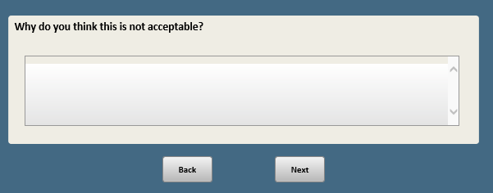Why do you think this is **[IF V2Q3=2 show:**not**]** acceptable?

**Create V2 [S]**

**Randomly assign respondents into V2=3 or V2=4. Separate seed from V1.**

Base: ASK IF V2=3

**V3Q1 [S]**

Now, please think about the following situation…

In an effort to improve the hiring process, some companies are now recording interviews with job candidates. These videos are analyzed by a computer, which matches the characteristics and behavior of candidates with traits shared by successful employees. Candidates are then given an automated score that helps the firm decide whether or not they might be a good hire.

How FAIR do you think this type of program would be to people applying for jobs?

1. Very fair
2. Somewhat fair
3. Not very fair
4. Not fair at all

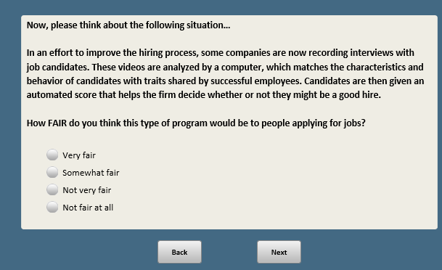

Base: ASK IF V2=3

**V3Q2 [S]**

How EFFECTIVE do you think this type of program would be at identifying good job candidates?

1. Very effective
2. Somewhat effective
3. Not very effective
4. Not effective at all

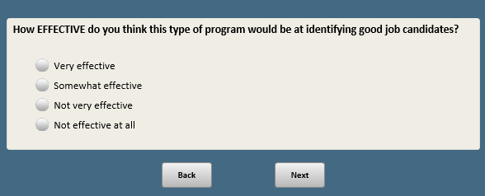

Base: ASK IF V2=3

**V3Q3 [S]**

Do you think it is acceptable or not for companies to use this type of program when hiring job candidates?

1. Acceptable
2. Not acceptable

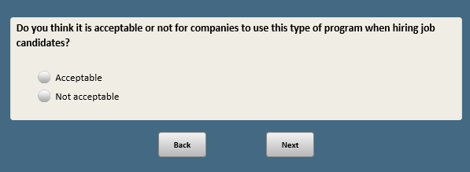

Base: ASK IF V3Q3=1 or 2

*Scripter: Allow as many characters as possible*

**V3Q4 [O]**

Why do you think this is **[IF V3Q3=2 show:**not**]** acceptable?

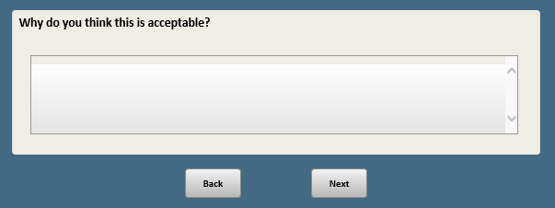

Base: ASK IF V2=4

**V4Q1 [S]**

Now, please think about the following situation…

In an effort to improve the hiring process, some companies are now using computers to screen resumes. The computer assigns each candidate an automated score based on the content of their resume, and how it compares with resumes of employees who have been successful. Only resumes that meet a certain score are sent to a hiring manager for further review.

How FAIR do you think this type of program would be to people applying for jobs?

1. Very fair
2. Somewhat fair
3. Not very fair
4. Not fair at all

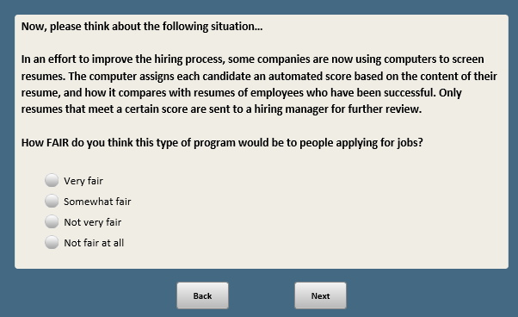

Base: ASK IF V2=4

**V4Q2 [S]**

How EFFECTIVE do you think this type of program would be at identifying good job candidates?

1. Very effective
2. Somewhat effective
3. Not very effective
4. Not effective at all

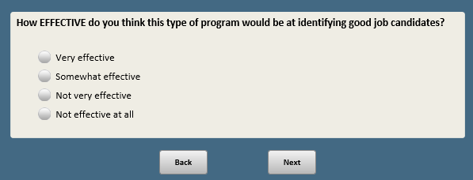

Base: ASK IF V2=4

**V4Q3 [S]**

Do you think it is acceptable or not for companies to use this type of program when hiring job candidates?

1. Acceptable
2. Not acceptable

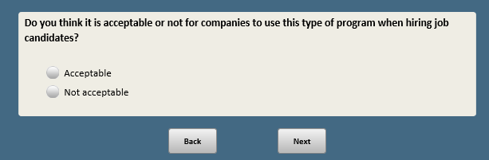

Base: ASK IF V4Q3=1 or 2

*Scripter: Allow as many characters as possible*

**V4Q4 [O]**

Why do you think this is **[IF V4Q3=2 show:**not**]** acceptable?

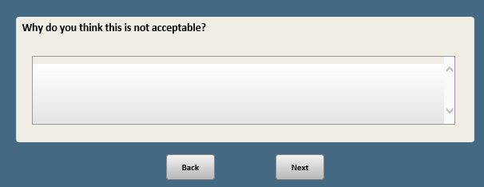

1. Open-end responses are excluded from public datasets to protect the confidentiality of ATP panelists